Drawing
[Fig. 1]
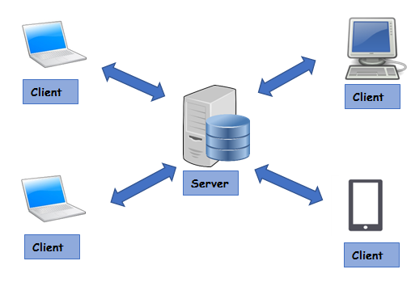
[Fig. 2]

